**Telcom Customer Churn Analysis**



There are Total 7043 customers

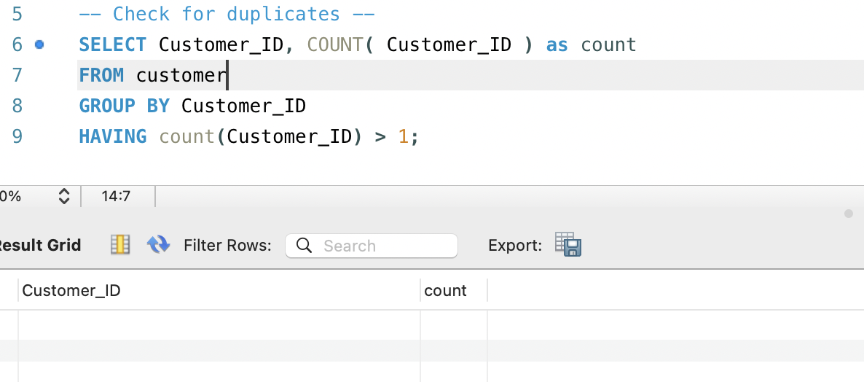

**Q1. What is the overall churn rate?**



The churn rate is **26.54%**, meant about 1 in 4 customers have left the company. This is relatively high and could indicate issues with customer satisfaction, service quality, or strong competitor offers. Further analysis is needed to identify the specific reasons behind this churn.

**Q2. What is the Revenue Lost Due to Churned Customers?**

Churned customers account for **17.2%** of the total revenue, which is a significant loss considering the high churn rate. This indicates that the company is not just losing customers, but also a considerable portion of its revenue.

**Q3. Churn Rate by Customer Tenure**

The churn rate is highest among customers with a tenure of **0–6 months** at **53.3%**, indicating that new customers are more likely to leave shortly after joining, possibly due to unmet expectations. This highlights the importance of focusing on improving the early customer experience to reduce churn. The churn rate decreases as tenure increases, with customers who’ve stayed for **25+ months** having the lowest churn rate at **14%**, suggesting that long-term customers are more loyal.

**Q4. What Contract are churned customers having?**

The churn rate is highest among **Month-to-Month** contract customers at **45.8%**, indicating they are more likely to leave due to the flexibility of their plans. In contrast, **One-Year** and **Two-Year** contract customers have significantly lower churn rates (**10.7%** and **2.5%**, respectively), suggesting that longer-term contracts help improve customer retention. This highlights the importance of promoting longer contracts to reduce churn.

**Q5. Which cities had the highest churn rates where we there is good customer base?**

**San Diego** has the highest churn rate at **64.9%** which meant more than half of its customers have left the company .It is significantly higher than other cities, indicating potential service issues or strong competitor presence.

**Q6. What are the general reasons for churn?**

The leading reason for churn is **Competitor-related** issues, accounting for **45%** of churned customers and the highest revenue loss. This suggests strong competition in the market, likely due to better pricing, features, or service quality. **Dissatisfaction (17.2%)** and **Attitude-related factors (16.8%)** are also significant, indicating potential issues with customer support or service experience. Addressing these areas through competitive offerings and improved customer support could help reduce churn.

**Q7. Specific reasons for churn**

The top specific reasons for churn are mostly related to **competitor offerings**, with **"Competitor had better devices" (16.7%)** and **"Competitor made better offer" (16.6%)**. This highlights the need for competitive pricing, device options, and value-added services. Additionally, **"Attitude of support person" (11.8%)** indicates issues with customer service quality,

**Q8. What offers did churned customers have??**

More than half of the churned customers (**56.2%**) had **no promotional offers**, indicating that the lack of incentives may have contributed to their decision to leave. In contrast, customers with offers like **Offer E (22.8%)** and **Offer D (8.6%)** still churned, suggesting these offers might not be compelling enough.

**Q9. What Internet Service Type did churned customers have?**

**Do they have internet service?**

Customers with internet service have a significantly higher churn rate (**31.83%**) compared to those without (**7.4%**), suggesting dissatisfaction with internet-related services.

**Fiber Optic** customers account for the majority of competitor-driven churn (**69.8%**).

**Q10. Internet Type for Competitor-Driven Churn**

The majority of competitor-driven churn comes from **Fiber Optic** customers, accounting for **69.8%** of the churn in this category. This suggests that competitors are offering better deals, faster speeds, or superior service quality specifically targeting Fiber Optic users. **DSL (14.9%)** and **Cable (12.7%)** customers also show some churn due to competitors, but at much lower rates.

**Q11. Did churners have premium tech support?**

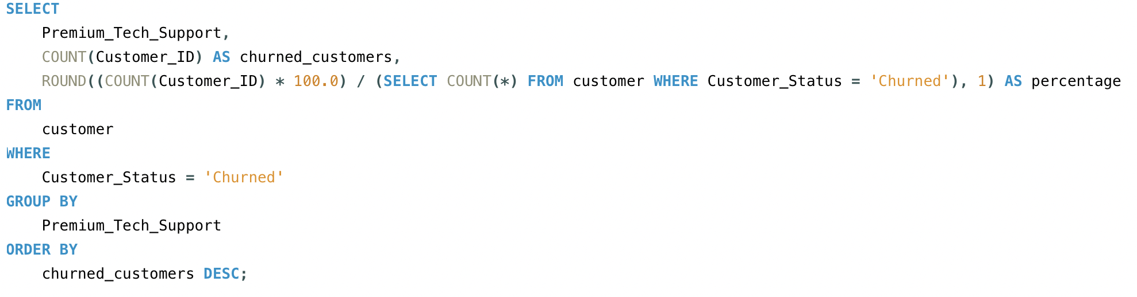

A significant majority of churned customers (**77.4%**) did **not** have premium tech support, suggesting that customers without access to premium support may feel less valued or receive inadequate assistance, leading to churn.

**Q12. How old were churned customers?**

There is a significant churn rate among customers aged **over 60 years** (**32.4%)** compared to other age groups.

**Q13. What Gender Were Churned customers ?**

**Q14. Do Churned customers Have Phone Lines?**

A significant majority of churned customers (**90.9%**) also had **phone service.**

**Q14. Customer Lifetime Value (CLV)**

**CLV=Monthly Charge×Tenure in Months**

This helps identify high-value customers who contribute the most to the company's revenue.

In this analysis, most high-CLV customers have long-term contracts, such as **Two-Year plans**, indicating strong retention.

Interestingly, some churned customers have a high CLV, which signals a potential revenue loss if such customers are not retained.

To identify **high-value customers**, we compared individual CLVs against the **average CLV**.

**Identifying High Valued Customers**

Customers with CLVs above the average were categorized as high-value, providing a clear segmentation for targeted strategies.

**Q15. Analyzing CLV Vs Churn**

The **Average CLV** of customers who have **stayed(tenure>4months)** is significantly higher (**$2,737.70**) compared to those who have **churned** (**$1,518.55**). This indicates that long-term, loyal customers contribute more revenue over time. However, the fact that customers with relatively high CLV are still churning suggests potential gaps in customer engagement or retention strategies. The **joined** segment has a much lower average CLV (**$78.09**) due to their short tenure(<=3 months).

**Key Insights:**

1. **High Overall Churn Rate:**  
   The churn rate is around **26.5%**, indicating that more than 1 in 4 customers are leaving, which is concerning for long-term revenue sustainability.
2. **Age-related Churn Trends:**
   * Customers **over 60 years** have the highest churn rate (**32.4%**), potentially due to technology adaptation issues.
   * Younger customers (**19–30 years**) also show higher churn**(~18%),** possibly due to price sensitivity and competitive offers.
3. **Contract Type Impact:**  
   Customers on **Month-to-Month contracts** have a churn rate of **45.8%**, significantly higher than those with **One-Year (10.7%)** or **Two-Year (2.5%)** contracts. This shows that long-term contracts help retain customers.
4. **Competitor Influence:**  
   **45%** of churned customers left due to competitors offering better deals, devices, or more data. Competitor-driven churn is particularly high among **Fiber Optic users (69.8%)**.
5. **Revenue Impact:**  
   Churned customers account for **17.2%** of total revenue loss, highlighting the financial impact of poor retention strategies.
6. **Service Dissatisfaction:**  
   Poor **customer support attitude (11.8%)** and **lack of premium tech support (77.4% of churners didn't have it)** contribute significantly to churn.
7. **Lack of Engagement:**  
   Over **56%** of churned customers had **no promotional offers**, and many churners **never referred** others, indicating low engagement levels.
8. **Customer Lifetime Value (CLV):**  
   The **average CLV** of churned customers is **$1,518**, significantly lower than that of retained customers (**$2,737**), indicating that the company is losing potential long-term revenue by not focusing enough on high-value customers.

**Recommendations:**

1. **Introduce & Promote Long-term Contracts:**  
   Offer **discounts, loyalty perks, or flexible upgrade options** to encourage customers to shift from month-to-month to longer-term contracts.
2. **Competitive Pricing & Offers:**  
   Develop **targeted campaigns** to counter competitors' offers, especially for **Fiber Optic customers**. Regularly benchmark competitor pricing and services.
3. **Enhance Customer Support:**  
   Train support staff to improve customer interaction quality. Consider offering **free premium tech support trials** to showcase its value.
4. **Engagement through Personalized Offers:**  
   Design **customized promotional offers** for at-risk customers, especially those without active offers. Use customer data to create **personalized retention plans**.
5. **Retention of High-Value Customers:**  
   Prioritize retention strategies for customers with **high CLV**, offering exclusive loyalty programs, proactive support, and personalized deals.
6. **Senior Customer Support:**  
   Introduce **simplified plans** and **dedicated support lines** for customers over 60 to address their specific needs and reduce churn in this segment.
7. **Feedback Loops:**  
   Implement regular **customer feedback surveys**, especially post-churn, to identify areas of dissatisfaction and improve services accordingly.